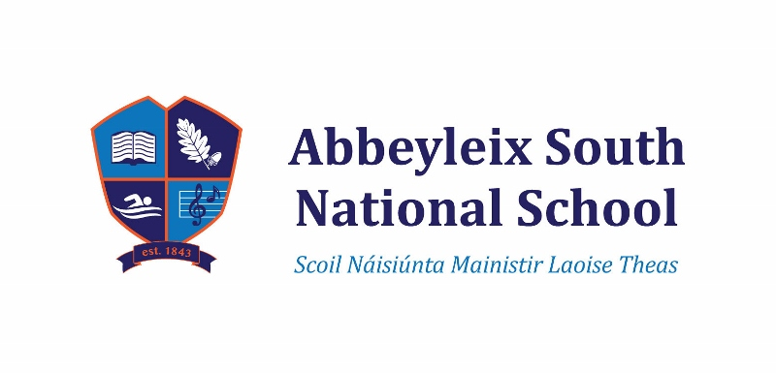
ANNUAL ADMISSION NOTICE
in respect of admissions to the 2023 – 2024 school year

Admission Policy and Application Form

A copy of the school’s Admission Policy and the Application Form for Admission for the 2023 - 2024 is available as follows: –
On request by emailing office@abbeyleixsouthns.ie
or writing to : Abbeyleix South National School, Ballacolla Road, Abbeyleix, Co. Laois, R32 PP79

Admissions to the 2023 – 2024 year

Application and Decision Dates for admission to 2023 - 2024
The following are the dates applicable for admission to Junior Infants

The school will commence accepting applications for admission on | 14th November  2022
The school shall cease accepting applications for admission on | 2nd Friday in January
The date by which applicants will be notified of the decision on their application is | 21 Days later
The period within which applicants must confirm acceptance of an offer of admission is | 2 weeks later

Note: the school will consider and issue decisions on late applications in accordance with the school’s Admission Policy.

Failure to accept an offer within the prescribed period above may result in the offer being withdrawn.

Number of places being made available in 2023 - 2024

The number of places being made available in Junior Infants | 13
Information regarding the admission process for the Intake Group for Junior Infants for 2022 - 2023

Breakdown of places allocated for the 2022 – 2023 school year:
Number of places available: | 13
Number of applications received: | 13
Number of Offers made and accepted under each criteria: | 13 | Priority Category 1  Priority Category 4 | 10  3
Total number of offers made | 13
Number of names placed on waiting list for the school year concerned. | 0

